Art World

Heroic Sanitation Workers Are Braving Exposure to Disinfect the Pyramids and Other Cultural Landmarks—See Surreal Pictures Here
From Stonehenge to the Pyramids of Giza, cultural spaces look very different right now than they usually do.
Artnet News, April 10, 2020
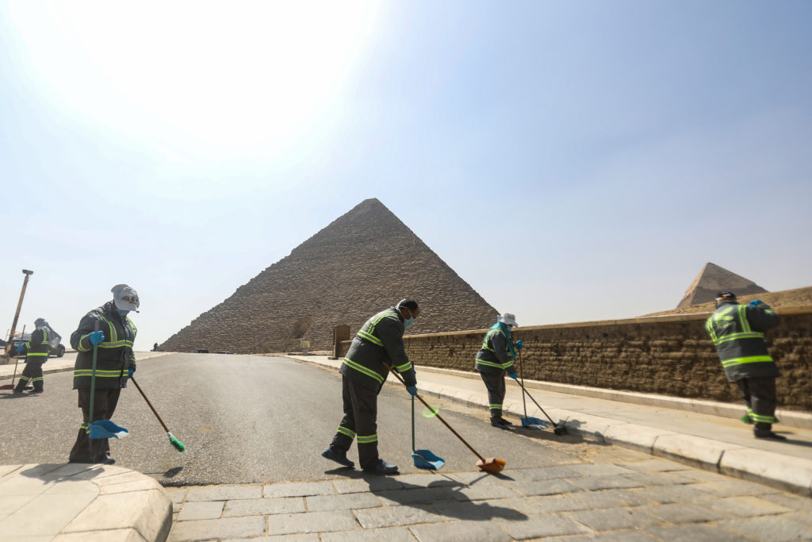Egyptian municipality workers disinfect the Giza pyramids necropolis outside Cairo. (Photo by Khaled DESOUKI / AFP)
From the Tower of Pisa in Italy to the Pyramids of Giza in Egypt, cultural landmarks and other public spaces that see thousands of visitors each year are now entirely vacant—except for the presence of sanitation workers who are braving dangerous conditions to disinfect them as the war against the novel coronavirus continues.
While non-essential workers are still housebound, pictures from around the world show surreal scenes of Tyvek suit-wearing workers spraying down eerily empty spaces like the Hagia Sophia in Istanbul and the Egyptian Museum in Cairo.
ADVERTISING
inRead invented by Teads
See the strange scenes—which, god willing, we are unlikely to witness again in our lifetime—below.
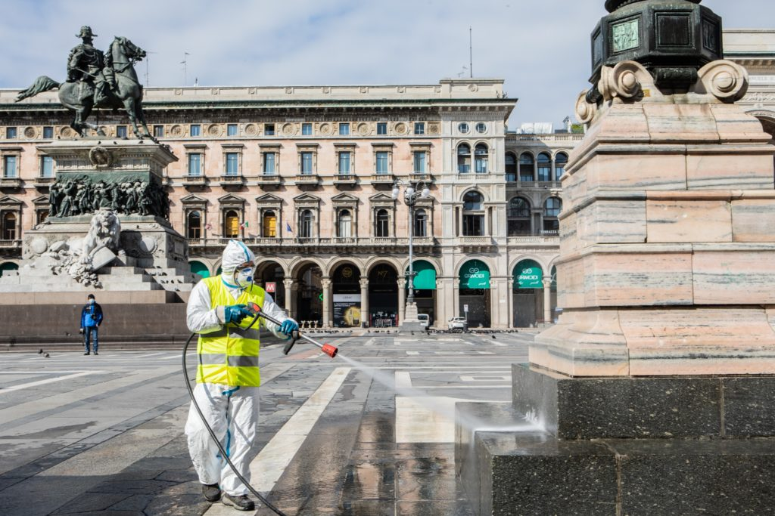
Sanitization of Piazza Duomo in Milan. (Photo by: Claudia Greco/AGF/Universal Images Group via Getty Images)
A worker sanitizes the Piazza del Duomo in Milan, Italy. (Photo by Pier Marco Tacca/Getty Images)
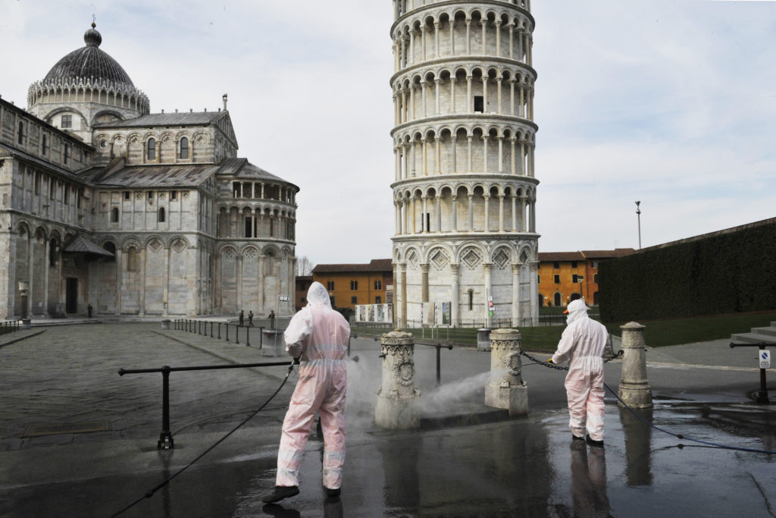
Sanitizing near the Tower of Pisa in Pisa, Italy. (Photo by Laura Lezza/Getty Images)
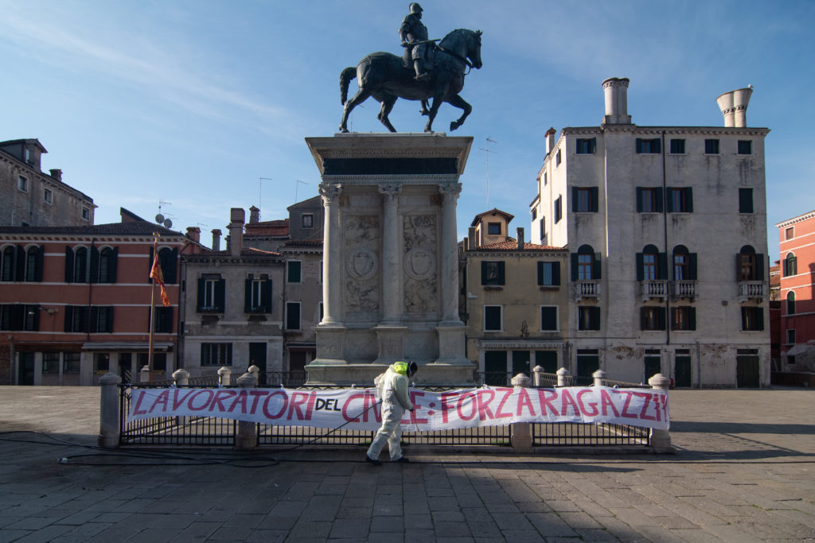
Sanitizing outside the Civil Hospital in Venice, Italy. (Photo by Simone Padovani/Awakening/Getty Images)
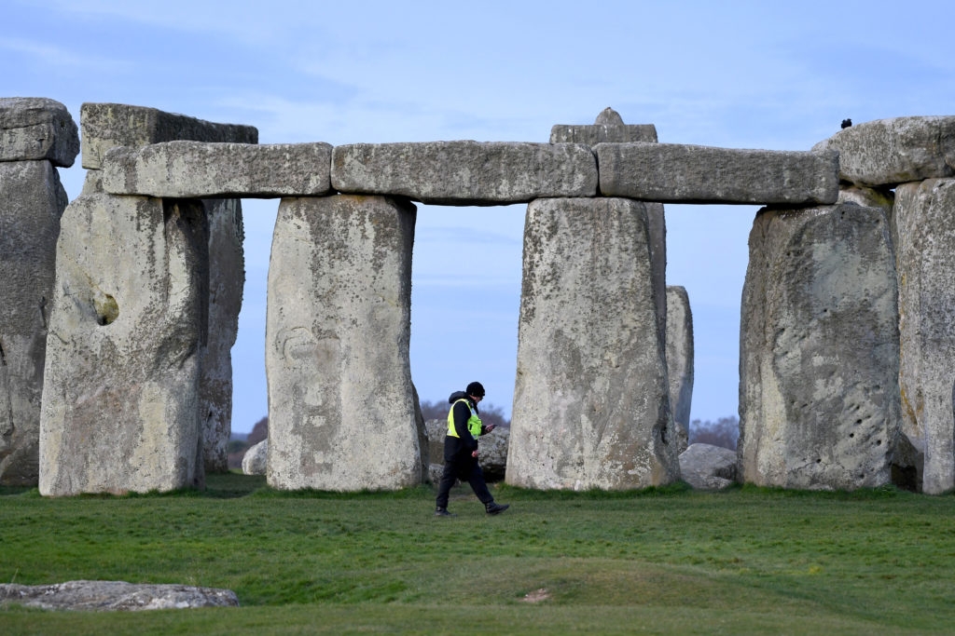
A security guard at the closed Stonehenge in Amesbury, United Kingdom. (Photo by Finnbarr Webster/Getty Images)
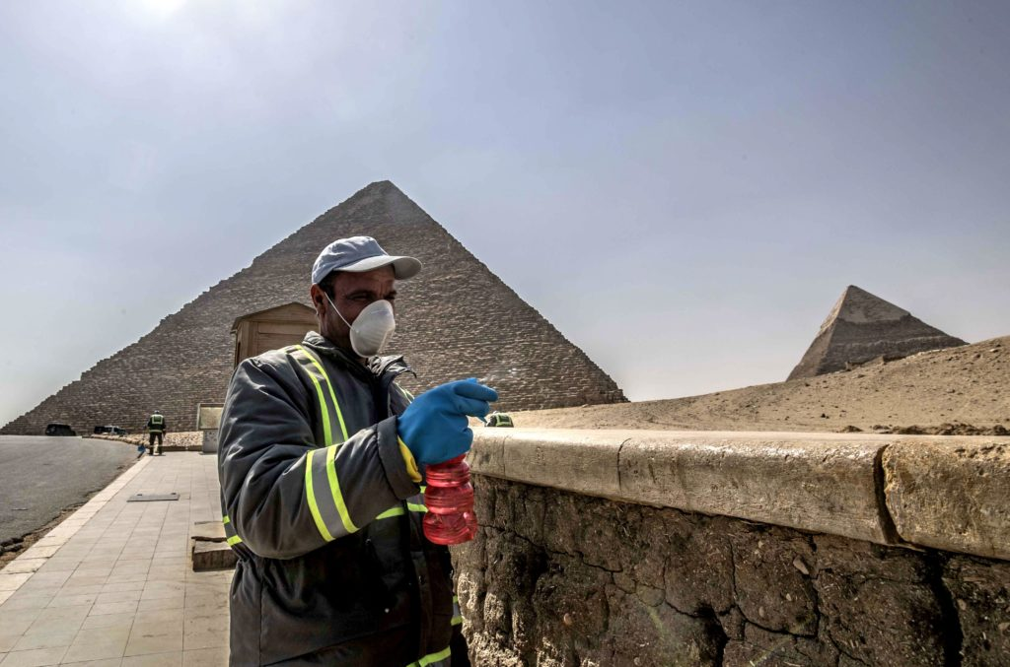
Egyptian municipality workers disinfect the Giza pyramids necropolis outside Cairo. (Photo by Khaled DESOUKI / AFP)
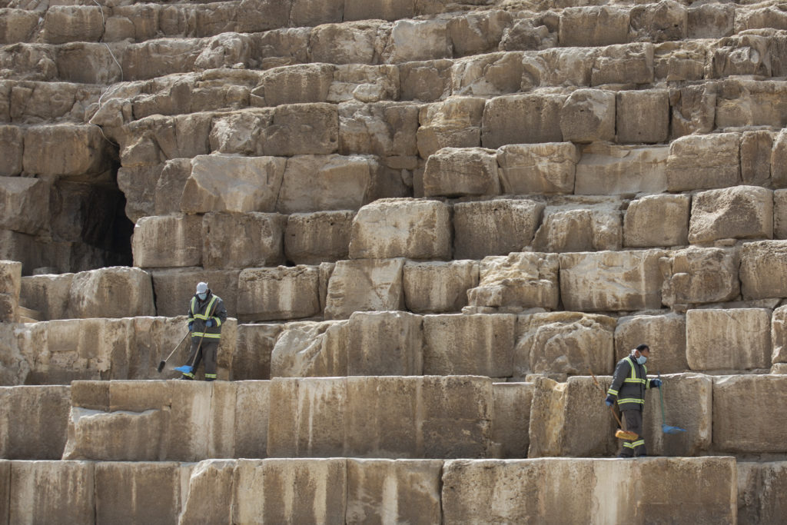
Egyptian municipality workers disinfect the Giza pyramids necropolis outside Cairo. (Photo by Khaled DESOUKI / AFP)
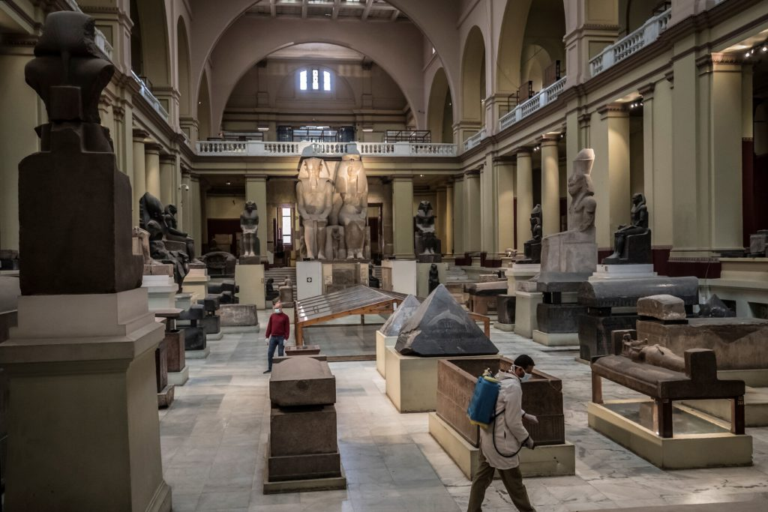
A worker disinfects the atrium of the Egyptian Museum in Cairo’s landmark Tahrir Square. (Photo by KHALED DESOUKI/AFP via Getty Images)
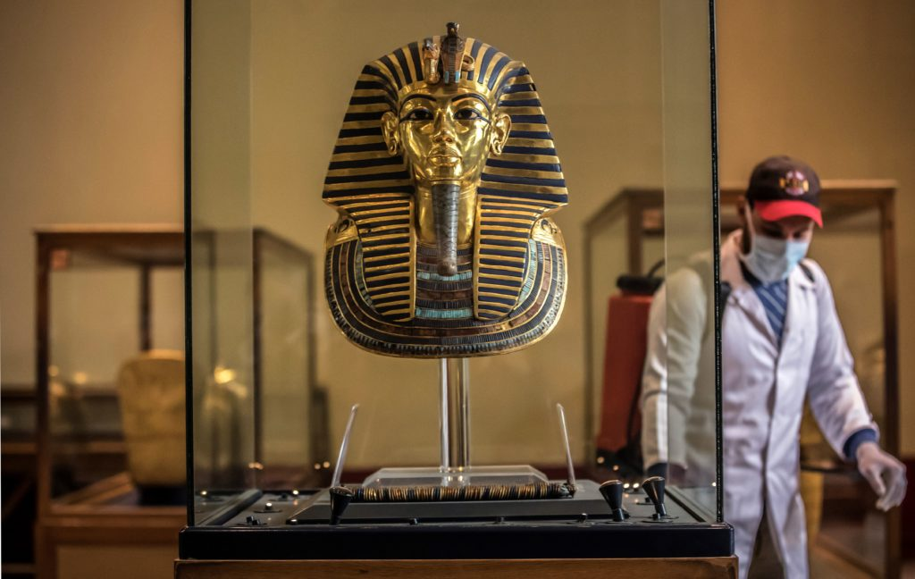
A worker disinfects the gallery of the ancient Egyptian Pharaoh Tutankhamun at the Egyptian Museum in Cairo. (Photo by KHALED DESOUKI/AFP via Getty Images)
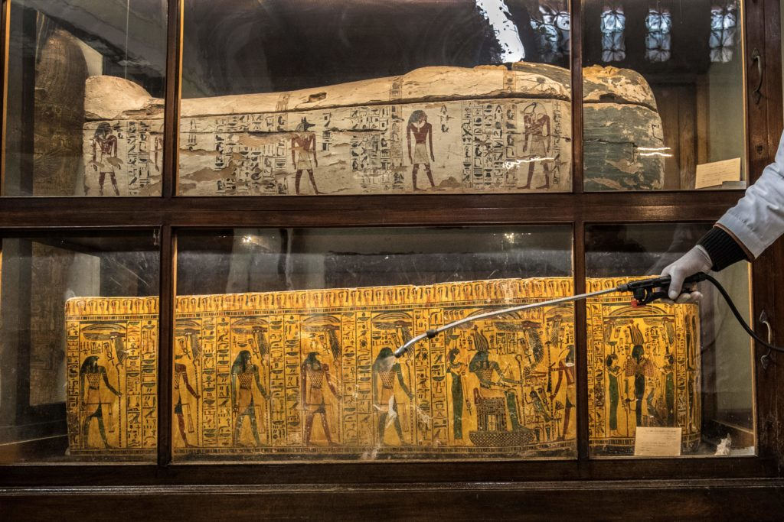
A worker disinfects the glass panels outside sarcophagi on display in a hall at the Egyptian Museum in Cairo’s landmark Tahrir Square. (Photo by KHALED DESOUKI/AFP via Getty Images)
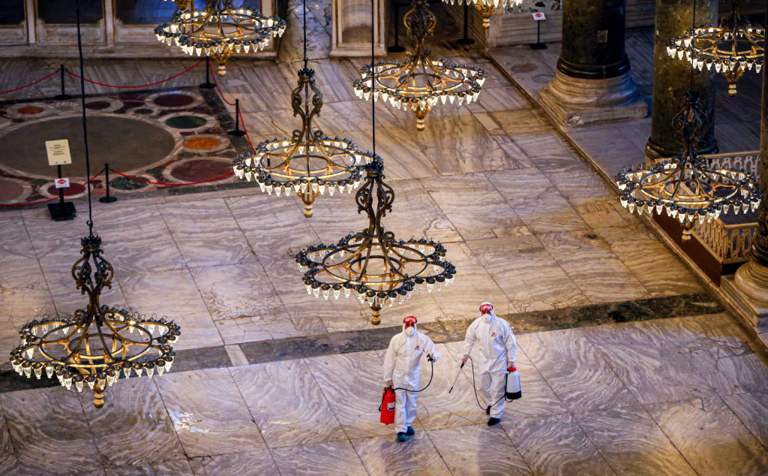
Health officials carry out disinfecting works at Hagia Sophia Museum in Istanbul, Turkey. (Photo by Mehmet Eser/Anadolu Agency via Getty Images)
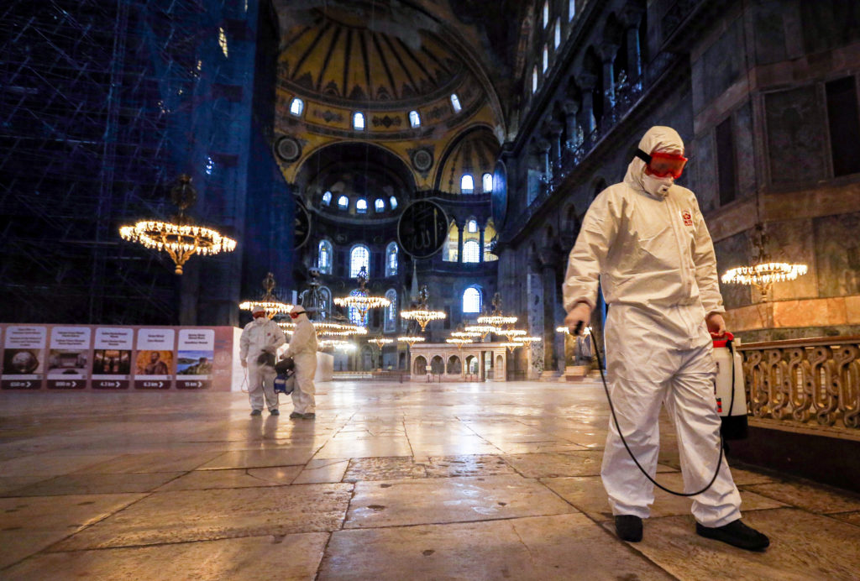
Health officials carry out disinfecting works at Hagia Sophia Museum in Istanbul, Turkey. (Photo by Mehmet Eser/Anadolu Agency via Getty Images)
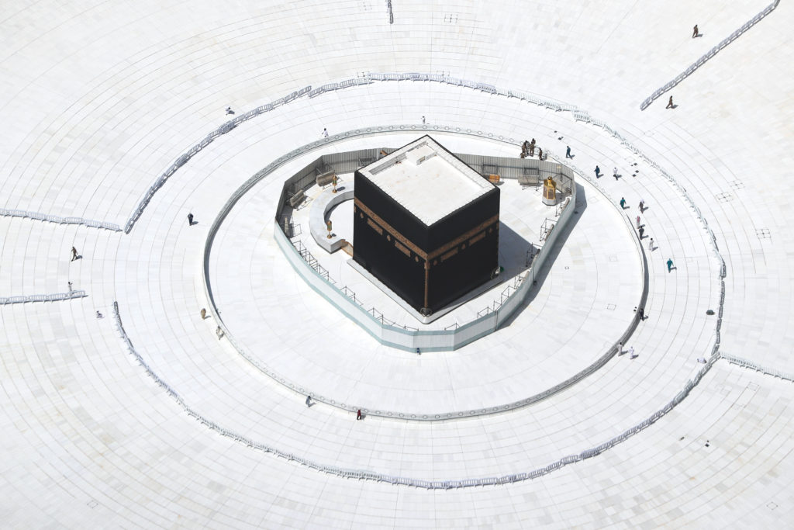
Mecca, Saudi Arabia, where International umrah visits have been halted since March 2nd and visits for Masjid al-Nabawi and Kaaba at the Masjid al-Haram have been suspended since March 20th. (Photo by Stringer/Anadolu Agency via Getty Images)
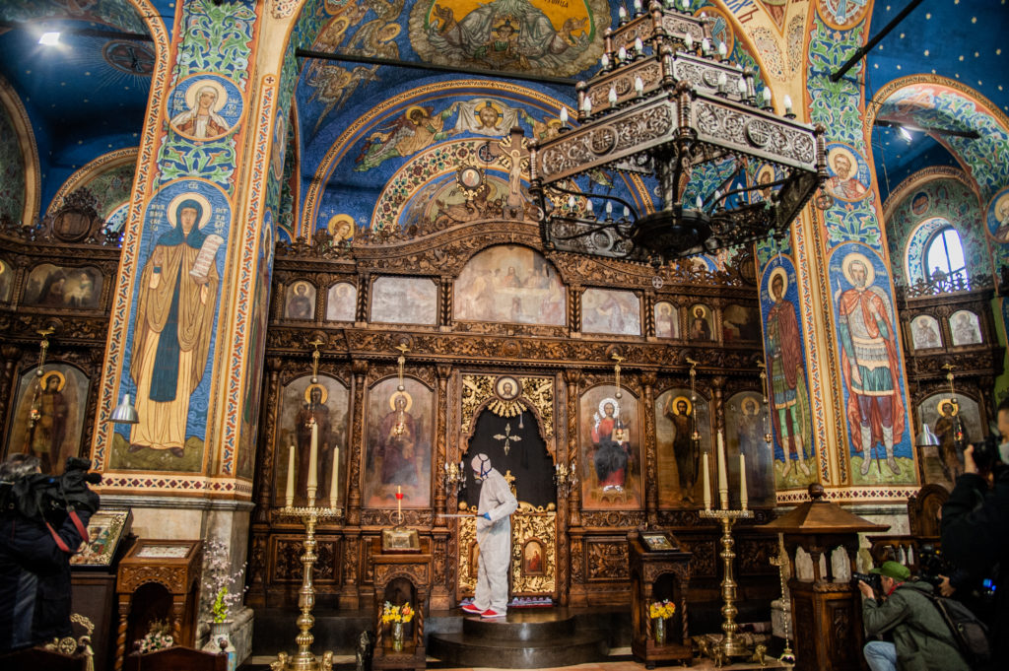
A Varna municipality worker, wearing a protective suit, sprays a liquid to disinfect Church St. Petka in Varna, Bulgaria. (Photo by Hristo Rusev/NurPhoto via Getty Images)
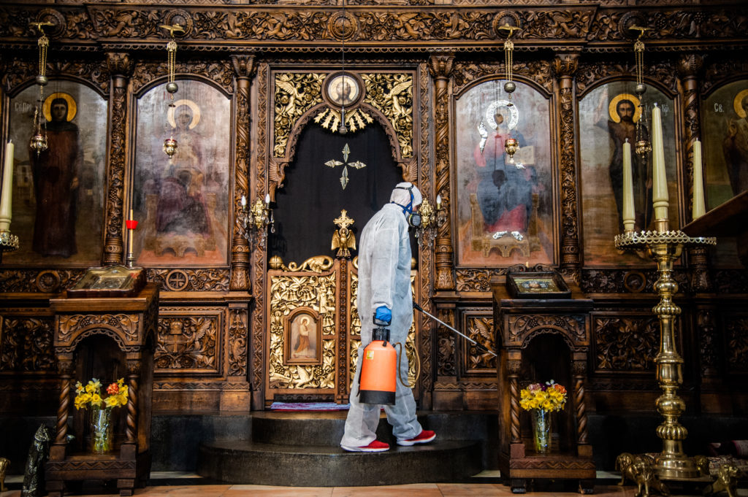
A worker sprays disinfectant in St. Petka Church in Varna, Bulgaria. (Photo by Hristo Rusev/NurPhoto via Getty Images)
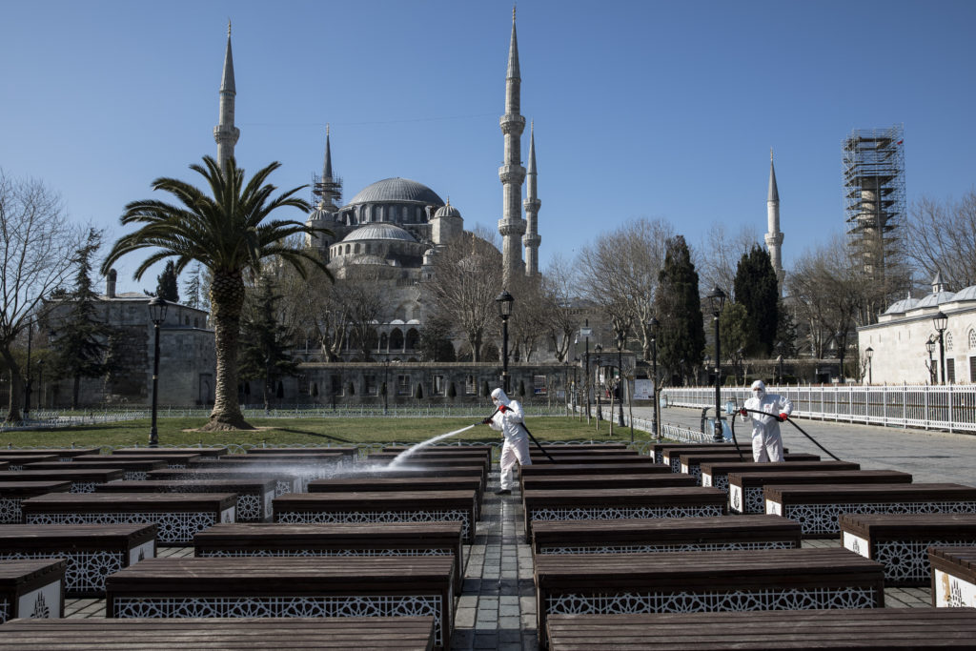
Istanbul Fatih Municipality disinfected the surroundings of Sultanahmet Square and the Hagia Sophia. (Photo by Onur Dogman/NurPhoto via Getty Images)

https://news.artnet.com/art-world/scenes-sanitation-landmarks-1831194

